Vaccine Safety and benefits
Image | Message
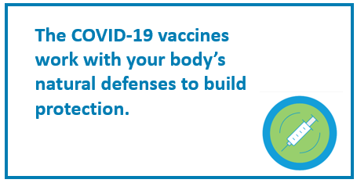 | Vaccines reduce the risk of getting a disease. They work with your body’s natural defenses to build protection. Vaccines train you body to fight a virus if it enters your body. This protection can reduce your risk of getting COVID-19.  For more information about COVID-19 vaccines, please visit: https://ckphu.com/covid-19-vaccine/
Vaccination is a proven way to reduce the impact of infectious diseases, including COVID-19. COVID-19 vaccines will help our bodies develop immunity to the virus that causes COVID-19 without us getting the illness.

Learn more at: canada.ca/COVIDvaccines
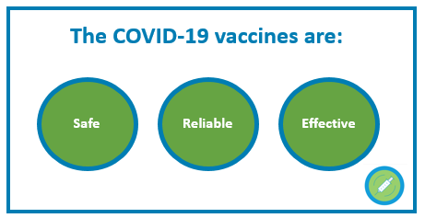 | While getting COVID-19 may offer some natural immunity, the risk of severe illness or death from COVID-19 far outweighs any benefits of natural immunity. Getting a vaccine will help protect you and your family.  Learn more about the vaccines at: https://ckphu.com/covid-19-vaccine/
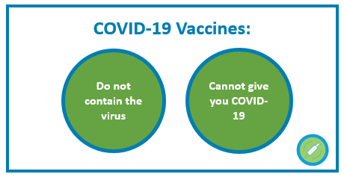 | None of the COVID-19 vaccines approved in Canada use the live virus that causes COVID-19. Symptoms like a fever after you get a vaccine is normal and a sign that your immune system is learning to fight the virus that causes COVID-19.  However, if you come into contact with the virus just before or after receiving the vaccine, you may get COVID-19 since your body will not have time to build up its immunity.  Learn more about the vaccines at: canada.ca/COVIDvaccines
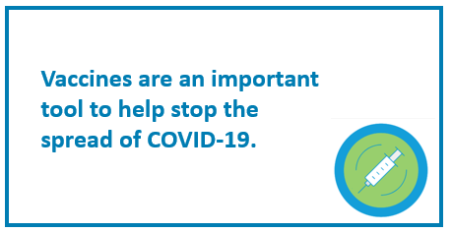 | Vaccination helps keep you from getting COVID-19. The vaccines available in Canada have been found to be effective at preventing COVID-19 in clinical trials.  Vaccines are an important tool to ending the pandemic.  For more information visit: https://ckphu.com/covid-19-vaccine/
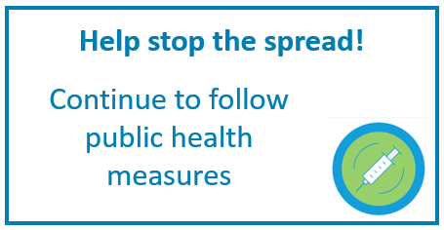 | Getting the COVID-19 vaccine is one part of keeping your, your family and your community healthy and safe. Help stop the spread by continuing to follow public health measures and getting the COVID-19 vaccine when your turn comes.  For more information about COVID-19 vaccines, please visit: https://ckphu.com/covid-19-vaccine/
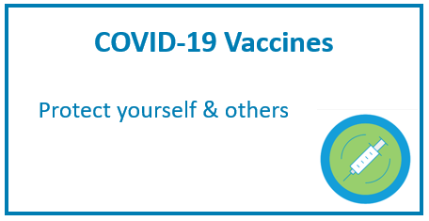 | Vaccines work with your immune system so your body will be ready to fight the virus if you are exposed. This can reduce your risk of developing COVID-19 and make your symptoms milder if you do get it.  Getting vaccinated as soon as you are eligible with the vaccine that is offered to you at that time, is the best way to protect yourself and others.  For more information about COVID-19 vaccines, please visit: https://ckphu.com/covid-19-vaccine/
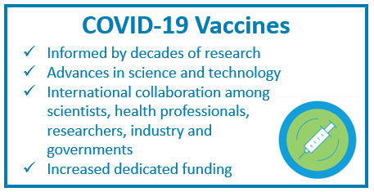 | The development of COVID-19 vaccines is happening quickly for many of reasons, including:  - being informed by decades of research  - advances in science and technology  - international collaboration among scientists, health professionals, researchers, industry and governments  - increased dedicated funding  Learn more about vaccine development at: canada.ca/COVIDvaccine
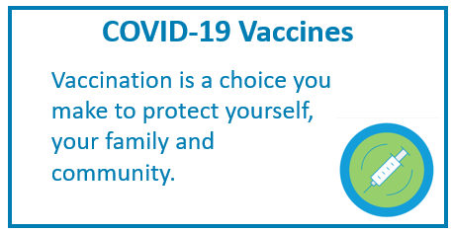 | The decision to get vaccinated is a personal choice. COVID-19 vaccines will not be mandatory in Ontario.  Getting vaccinated will help to protect you, your family, friends and community.  Learn more about COVID-19 vaccines at:  https://ckphu.com/covid-19-vaccine/
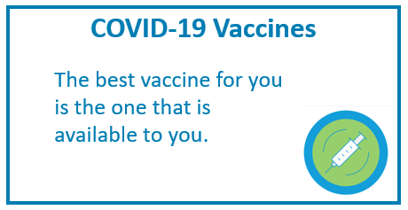 | With multiple COVID-19 vaccines now approved for use in Canada, the best vaccine for you is the one that is available to you.  Getting vaccinated as soon as you are eligible with the vaccine that is offered to you at that time, is the best way to protect yourself and others.  For more information about COVID-19 vaccines, please visit: https://ckphu.com/covid-19-vaccine/

Vaccine Rollout
Image | Message
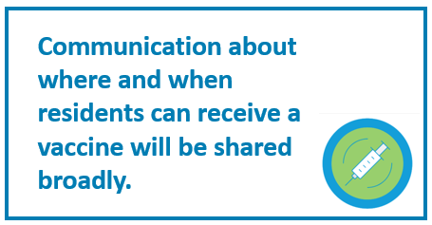 | As the Province rolls out its three-phased vaccine distribution implementation plan, CK Public Health will share information about where and when residents can get vaccinated.  For local updates about vaccines, please visit: https://ckphu.com/covid-19-vaccine/
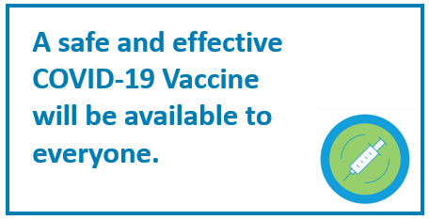 | COVID-19 vaccines are arriving in Chatham-Kent in stages. Priority populations identified by the Province will get vaccines first. Vaccines will be available to everyone over the course of 2021. For more information about vaccine distribution, please visit: https://ckphu.com/covid-19-vaccine/
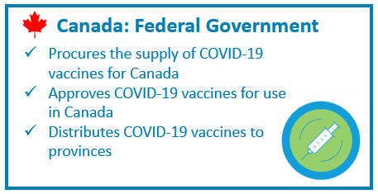  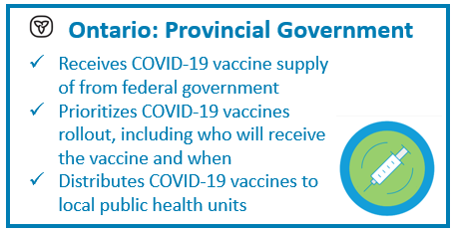  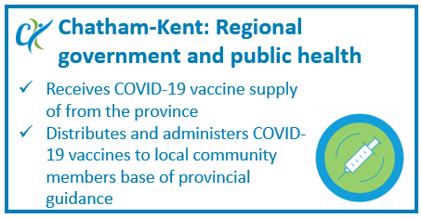 | All levels of government play a part in rolling vaccines out:  - Federal government: approves vaccines to ensure their safety and buys Canada’s supply canada.ca/COVIDvaccine  - Provincial Government: distributes and identifies priority groups ontario.ca/COVIDvaccine  - Regional government: supports local rollout https://ckphu.com/covid-19-vaccine/

Reliable sources for vaccine information
Image | Message
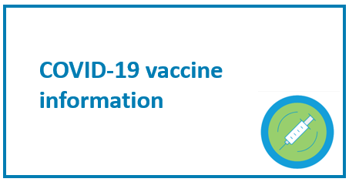 | Stay up to date with the facts about the COVID-19 vaccine. Get your information from reliable sources:  CK Public Health: https://ckphu.com/covid-19-vaccine/  Ontario Ministry of Health ontario.ca/COVIDvaccine  Health Canada canada.ca/COVIDvaccine
Want to learn more about how vaccines are developed in Canada? Check out this video from @GovCanHealth: https://www.youtube.com/watch?v=Y51ZgZCS8J0&feature=youtu.be
For local information about the COVID-19 vaccines, please visit: https://ckphu.com/covid-19-vaccine/
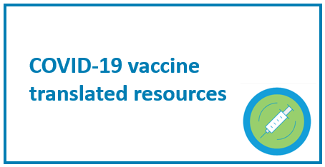 | Looking for translated COVID-19 vaccine information? For COVID-19 vaccine fact sheet available in many languages, visit https://ckphu.com/covid-19-vaccine/

General vaccine updates
Image | Message
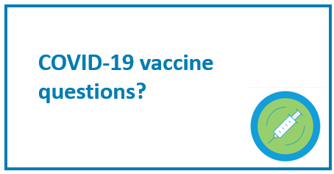 | Questions about the COVID-19 vaccine? Check out CK Public Health’s COVID-19 Vaccine FAQ: https://ckphu.com/covid-19-vaccine/
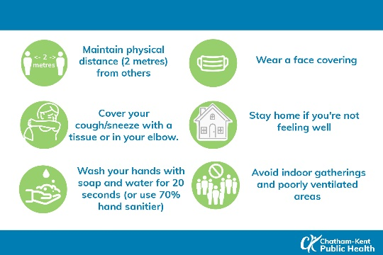 | Building immunity takes time. If you come into contact with the virus just before or after receiving the vaccine, you may get COVID-19 since your body will not have time to build up its immunity.  While you wait for your turn to receive the vaccine and after you get it, we need to continue to follow the public health measures to keep everyone safe.  For more information visit: https://ckphu.com/covid-19-vaccine/
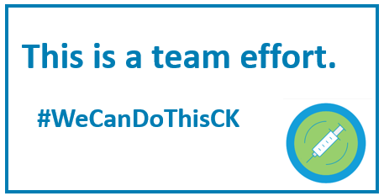 | COVID-19 vaccination builds defenses against COVID-19. This is a team effort. We all play a key part of the defence.  Getting the COVID-19 vaccine adds one more layer of protection for you, your family, friends, and our community.  While you wait for your turn to receive the vaccine and after you get it, we need to continue to follow the public health measures to keep everyone safe.  #WeCanDoThisCK

