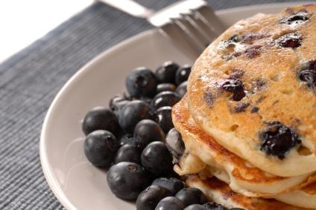
Whole Wheat Blueberry Pancakes

Ingredients

Whole wheat flour 1 ¼ cups
Baking powder 2 teaspoons
Eggs 1 large
Milk 1 cup
Salt ½ teaspoon
Sugar 1 tablespoon
Blueberries ½ cup
(you can use fresh, or frozen blueberries.
If using frozen berries, place them in the batter
frozen.)

Directions

- Spray large skillet with cooking spray and preheat over medium heat.
- In a small bowl, sift together flour and baking powder. Set aside.
- In a large bowl, beat together milk, egg, salt and sugar. Stir in flour mixture until just moistened. Add blueberries and stir to incorporate them.
- Pour batter into skillet, about ¼ cup batter per pancake.
- Cook until bubbling, about 1 ½ minutes. Turn and cook until golden brown.
- Serve and top with blueberries or other fruit of choice.
- Makes about 10 pancakes.

Makes 5 servings.
1 serving = 2 pancakes

Adapted from: Allrecipes.com

